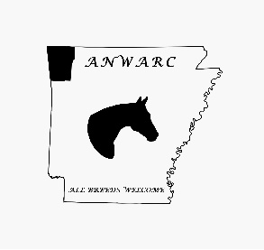 2024 ANWARC Sponsorship Form
Please make checks payable to: ANWARC
Mail form with payment to: ANWARC PO Box 264 Cave Springs, AR 72718

Name: __________________________________________________________________
Name to be announced in ads: _______________________________________________
Phone Number: ___________________________________________________________
Address: _________________________________________________________________
Email: ___________________________________________________________________
Website:_________________________________________________________________
See level descriptions in packet. All sponsors get class sponsor announcement at shows.
$25-$49= Friends____________
$50-$99= Bronze____________
$100-$249= Silver___________
$250-$500= Gold____________
>$500= Platinum____________
Amount Paid________________ Cash_______ Check_______ Check #_________
For Year End Awards- Individual Sponsor($50)_____ Family Sponsor($75)_____
ANWARC Member being Sponsored________________________________________

Please include business card or Logo along with form and payment to Dianna Watson at the address listed above and email a digital copy to anwarcinfo@gmail.com

